**6G4Z0016 Databases**

**Introduction to MariaDB Databases and SQL**

**Part 3: Basic Queries and WHERE Statements**

**Aim**

The aim of this session is to be able to write simple SQL queries and WHERE statements.

**Activities**

**Part 1 Basic Queries**

1. View the Human Resources schema information on Moodle to familiarise yourself with entities, attributes and relationships. (Appendix 1 - at the bottom of this document, or in the Introduction to Databases lecture, slide 8.)
2. Type the following queries into MySQL WorkBench and execute them separately

***Query 1:***

SELECT *

FROM departments;

***Query 2:***

SELECT department_id, department_name, manager_id, location_id

FROM departments;

What do you notice? - Write your observations in the text box below.

1. Write an SQL statement to display the structure of the Employees table– record your answer below. *Tip: Search the MariaDB knowledge base (*[*https://mariadb.com/kb/en*](https://mariadb.com/kb/en)*) for “describe table” or “show columns”:*
2. Write a query to show all the records in the EMPLOYEE’s table. – record your answer below.
3. What output does the following query produce?

SELECT last_name, 12*salary*commission_pct

FROM employees;

1. Type in and execute the following query:

SELECT DISTINCT department_id

FROM employees;

What does the DISTINCT keyword in SQL do? (Try the query without it.)

1. Some columns in a database table can contain NULL values. For example, if you type in the following query you will see NULL values in the commission_pct column.

SELECT last_name, job_id, salary, commission_pct

FROM employees;

What is a NULL Value? Record your answer in the text box below. *Tip: Search the MariaDB knowledge base for “NULL Values”:*

1. Can you remove the NULLs from the result of the query in question 5 ?? *Tip: Search the MariaDB knowledge base for “NULL commands”:*
2. When displaying the result of a query, MySQL Workbench normally uses the name of the selected column as the column heading. This heading may not be descriptive and, therefore, may be difficult to understand. You can change a column heading by using a column alias.

Type in and execute the query below and notice how the column name salary has been replaced by the Alias “Annual Salary”.

Now that you know the basics, use your SQL knowledge to answer the following questions:

1. The following SELECT statement executes successfully:

SELECT last_name, job_id, salary AS Sal

FROM employees;

**True** or False

1. There are four coding errors in the following statement. Can you identify them?

SELECT employee_id, last_name

sal x 12 ANNUAL SALARY

FROM employees;

#

1. Write a query to display the last name, job ID, hire date, and employee ID for each employee, with the employee ID appearing first. Provide an alias STARTDATE for the HIRE_DATE column.
2. Write a query to display all unique job IDs from the EMPLOYEES table.
3. Sometimes it looks nicer when we provide more descriptive column headings in reports. Run the query in (12) again but now with columns entitled: Emp #, Employee, Job, and Hire Date.
4. Write a query to display all employees and their job IDs. Display the last name concatenated with the job ID (separated by a comma and space) and name the column Employee and Title. *Tip: Search the MariaDB knowledge base (*[*https://mariadb.com/kb/en*](https://mariadb.com/kb/en)*) to find out how CONCAT works:*

**Part 2 WHERE Clause**

Answer the following questions (make sure to save and record all your answers):

1. In SQL, the WHERE Clause is used to restrict the number of rows returned from the database. Type in the following query and execute it.

SELECT *

FROM employees

WHERE department_id = 90;

Observe what is shown on the screen. Change the department_id to other values for department_id and rerun the query. (*Hint: If you can’t remember other values write yourself a query to show all details in the departments table*).

1. Type the following queries into MySQL Workbench and execute them separately

***Query 1:***

SELECT last_name, salary

FROM employees

WHERE salary BETWEEN 2500 and 3500;

***Query 2:***

SELECT last_name, salary

FROM employees

WHERE salary>=2500 AND salary<=3500;

What do you notice about the output ?

1. Write an SQL statement to display ALL information about employees whose salary is less than or equal to 4000. Record your answer below.

Select * from employees where salary <=4000;

1. In the following query, the % symbol is used as a wild card and represents a series of zero or more characters. Type in the query below and execute it.

SELECT first_name

FROM employees

WHERE first_name LIKE BINARY 'S%';

What does the above query display? Write your answer below.

Note that MariaDB is very particular about the single quotation marks, used for dealing with string matches, being like this “ ' ”, and not like this “ ` ”.

1. Write a query to display the names of departments that start with the capital letter ‘M’.

*Hint: Writing a simple query and do not know where to start?* Follow these three steps:

i) What data do I need?

ii) What tables is the data stored in?

iii) Are there any conditions?

Write your answer in the box below:

Select departments from dep where like “M%”

1. Sometimes values in a data field are NULL values. Type in the query below and execute it.

SELECT last_name, manager_id

FROM employees

WHERE manager_id IS NULL;

Try and understand what this query does. If you removed the last line i.e. the WHERE clause and re-ran the query, what would happen?

Would show all values

What result do you get if you replace the “IS” in the above query with “=”. What does that tell you?

Nothing as nothing can equal null because it has no value

1. The IN operator in SQL is used to test to see if data items are members of a list. Suppose the Director of a company wanted to know all the employee’s managed by manager 100, 101 and 201 – then they would write the following query.

SELECT employee_id, last_name, salary, manager_id

FROM employees

WHERE manager_id IN (100,101,201);

Write a query using the IN statement, that displays the employee_id, last_name, department_id and manager_id for employees whose last name is ‘Hartstein’ or ‘Vargas’.

Write your answer below:

Appendix 1:

Human Resources Schema

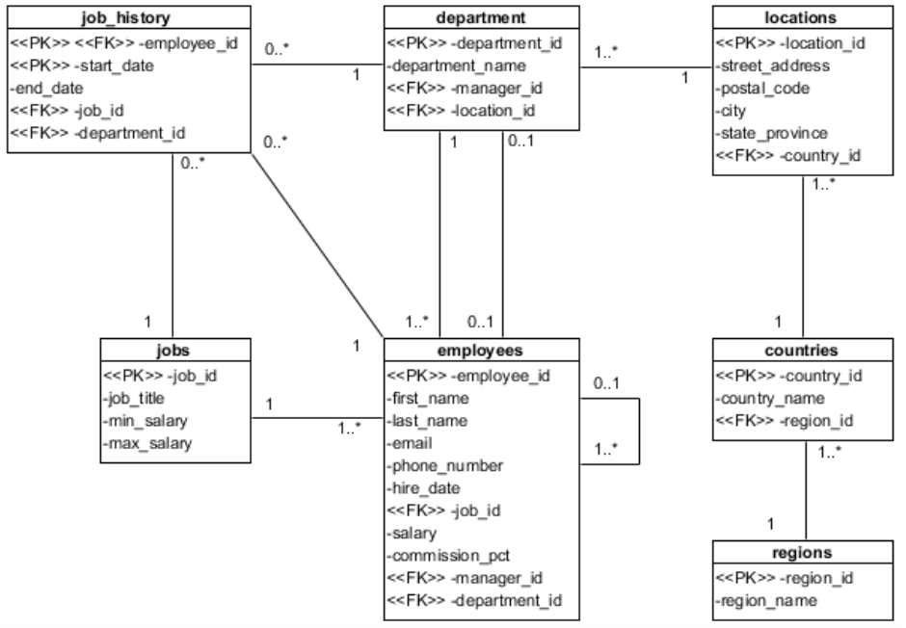

(Oracle, 2012)